Partial Differential Equations
School of Applied and Basic Sciences
Course Name : Linear Algebra and Differential Equations Course Code : BMA201
Date:08 April 20
Serial No. | Question  Number | CO | Bloom’s Taxonomy Level | Difficulty Level | Competitive Exam Question Y/N | Area | Topic | Unit | Marks
1 | Classify the second order linear PDE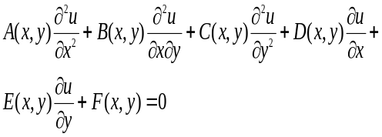, for following given value of A, B, C  A=1 , B= 0, C=3 | 5 | K4 | L | N | PDE | Classification of second order PDE | 5 | 2
2 | Classify the second order linear PDE, for following given value of A, B, C  A=-2 , B= 3, C=-4 | 5 | K4 | L | N | PDE | Classification of PDE | 5 | 2
3 | Classify the second order linear PDE, for following given value of A, B, C  A= -4 , B=-2 , C=-1 | 5 | K4 | L | N | PDE | Classification of PDE | 5 | 2
4 | Classify the second order linear PDE, for following given value of A, B, C  A= 2 , B=2 , C= 2 | 5 | K4 | L | N | PDE | Classification of PDE | 5 | 2
5 | Classify the second order linear PDE, for following given value of A, B, C  A=-5 , B=-5, C=-5 | 5 | K4 | L | N | PDE | Classification of PDE | 5 | 2
6 | Classify the second order linear PDE, for following given value of A, B, C  A=100, B=10, C=10 | 5 | K4 | L | N | PDE | Classification of PDE | 5 | 2
7 | Classify the second order linear PDE, for following given value of A, B, C  , , | 5 | K4 | L | N | PDE | Classification of PDE | 5 | 2
8 | Classify the second order linear PDE, for following given value of A, B, C  , , | 5 | K4 | L | N | PDE | Classification of PDE | 5 | 2
9 | Classify the second order linear PDE, for following given value of A, B, C  , , | 5 | K4 | L | N | PDE | Classification of PDE | 5 | 2
10 | Find the region for which the second order linear PDE, is parabola/Hyperbola/Ellipse for following values of A, B, C, D, E ,F  , , , , , | 5 | K1 | L | N | PDE | Classification of PDE | 5 | 2
11 | Find the region for which the second order linear PDE, is parabola/Hyperbola/Ellipse for following values of A, B, C, D, E ,F  , , , , , | 5 | K1 | L | N | PDE | Classification of PDE | 5 | 2
12 | Find the region for which the second order linear PDE, is parabola/Hyperbola/Ellipse for following values of A, B, C, D, E ,F  , , , , , | 5 | K1 | L | N | PDE | Classification of PDE | 5 | 2
13 | Classify the following 2nd order homogeneous linear differential equations. Show the details of your work: 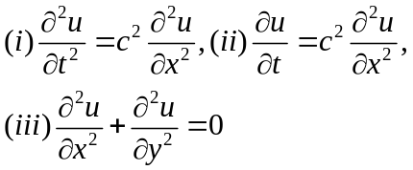. | 5 | K4 | L | N | PDE | Classification of PDE | 5 | 2
14 | Classify the partial differential equation  for region x>0, y>0. | 5 | K4 | M | Y | PDE | Classification of PDE | 5 | 2
15 | Find region in which partial differential equation is hyperbolic? [GATE2011] | 5 | K1 | M | Y | PDE | Classification of PDE | 5 | 2
16 | Solve partial differential equations :(Exa. 9.15/9.30/J)  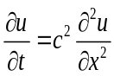 | 5 | K3 | M | N | PDE | Method of Separation of Variable | 5 | 6
17 | Solve partial differential equations :  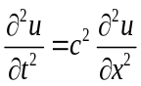 | 5 | K3 | M | N | PDE | Method of Separation of Variable | 5 | 6
18 | Solve partial differential equations :  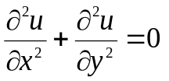 | 5 | K3 | M | N | PDE | Method of Separation of Variable | 5 | 6
19 | Solve partial differential equations :  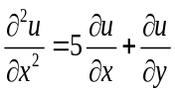 | 5 | K3 | M | N | PDE | Method of Separation of Variable | 5 | 6
20 | Use separation of variables method to solve following PDE: (9,10/Exc. 9.4/9.50/J)  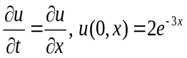 | 5 | K3 | M | N | PDE | Method of Separation of Variable | 5 | 6
21 | Let u(x,t) be the solution of initial value problem ,  Then find value of , [GATE2006] | 5 | K3 | H | Y | PDE | Heat Equation | 5 | 6
22 | Find the solution of initial value problem , , and [GATE2009] | 5 | K3 | H | Y | PDE | Heat Equation | 5 | 6
23 | Let u(x,t) be the solution of initial value problem , Then find value of , [GATE2010] | 5 | K3 | H | Y | PDE | Wave Equation | 5 | 6
24 | Use separation of variables method to solve following PDE:  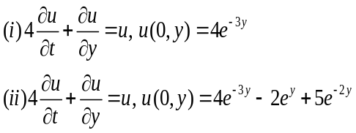 | 5 | K3 | M | N | PDE | Method of Separation of Variable | 5 | 6
25 | Solve the following initial boundary value problem corresponding to the one-dimensional wave equation:  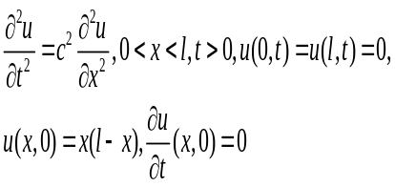 | 5 | K3 | M | N | PDE | Wave Equation | 5 | 9/10
26 | Solve the following initial boundary value problems corresponding to the one-dimensional heat equation:  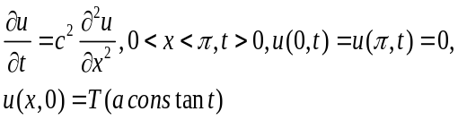 | 5 | K3 | M | N | PDE | Heat Equation | 5 | 9/10
27 | Find the steady-state solutions (temperatures) in the square plate 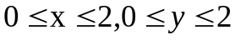if the upper side is kept at the temperature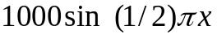and the other sides are at 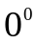. | 5 | K3 | M | N | PDE | Heat Equation | 5 | 9/10
28 | Solve the following one-dimensional wave equation:  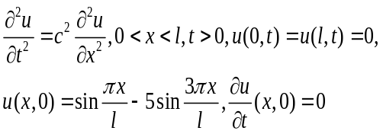 | 5 | K3 | M | N | PDE | Wave Equation | 5 | 9/10
29 | Solve the following one-dimensional heat equation: 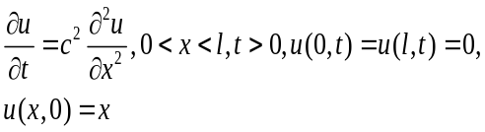 | 5 | K3 | M | N | PDE | Heat Equation | 5 | 9/10
30 | Solve the Laplace equation by the separation of variables method : 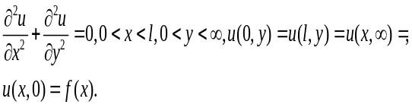 | 5 | K3 | M | N | PDE | Laplace Equation | 5 | 9/10
31 | An elastic string of length which is fastened at the ends 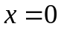and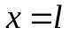is picked up at its centre point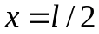to a height of 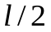and released from rest. Find the displacement of the  string at any instant of time. (Exa.9.17/9.40/J) | 5 | K3 | M | N | PDE | Wave Equation | 5 | 9/10
32 | An elastic string of length which is fastened at the ends andis released from its horizontal position (zero initial displacement) with initial velocity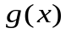 given as:  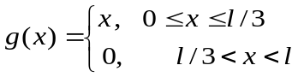 Find the displacement of the string at any instant of time. (Exa.9.18/9.41/J | 5 | K3 | M | N | PDE | Wave Equation | 5 | 9/10
33 | Solve the following initial boundary value problem corresponding to the one-dimensional wave equation:  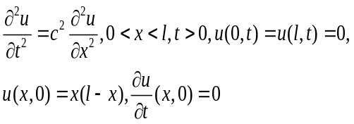 | 5 | K3 | M | N | PDE | Wave Equation | 5 | 9/10
34 | Solve the following initial boundary value problem corresponding to the one-dimensional heat equation:  (23/Exc.9.4/9.51/J) | 5 | K3 | M | N | PDE | Wave Equation | 5 | 9/10
35 | Find the temperature in a laterally insulated bar of length L whose ends are kept at temperature 0, assuming that the initial temperature is 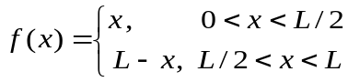.(Exa.3/562/K) | 5 | K3 | H | N | PDE | Heat Equation | 5 | 9/10
36 | Solve the Laplace equation: 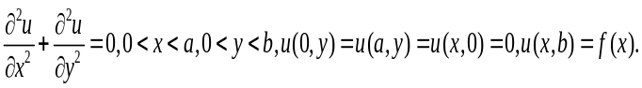(Exa.1/561/K) | 5 | K3 | M | N | PDE | Laplace Equation | 5 | 9/10
37 | Find the steady-state solutions (temperatures) in the square plate if the upper side is kept at the temperatureand the other sides are at . (19/Exc.12.6/567/K) | 5 | K3 | M | N | PDE | Heat Equation | 5 | 9/10
38 | Find the solution of initial value problem , , and [GATE2012] | 5 | K3 | H | Y | PDE | Heat Equation | 5 | 9/10
39 | Let u(x,t) be the solution of initial value problem , Then find value of , [GATE2013] | 5 | K3 | H | Y | PDE | Wave Equation | 5 | 9/10
40 | Let u(x,t) be the solution of initial value problem , Then find value of , [GATE2014] | 5 | K3 | H | Y | PDE | Wave Equation | 5 | 9/10
41 | The boundary value problem governing the steady-state temperature distribution in a flat, thin, rectangular plate is given by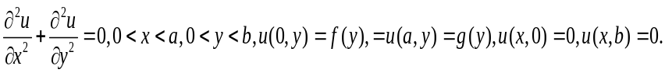 (49/Exc.9.4/9.54/J) | 5 | K3 | M | N | PDE | Laplace Equation | 5 | 9/10

Signature of Course Coordinator:
Signature of PC:
Signature of Dean:
IQAC:
Appendix II :
Bloom’s Taxonomy Levels Distribution of Questions in Question Bank
School of Basic and Applied Sciences Date : 13/12/18
Course Name : Linear Algebra and Differential Equations Course Code : MATH1006
Serial No. | Bloom’s Taxonomy Level | Percentage Distribution
1 | Knowledge | 10%
2 | Understand | 30%
3 | Apply | 60%

Signature of Course Coordinator:
Signature of PC:
Signature of Dean:
IQAC:

Appendix III :
Bloom’s Taxonomy Levels Distribution of Questions in Question Bank
School of Basic and Applied Sciences Date : 13/12/18
Course Name : Linear Algebra and Differential Equations Course Code : MATH1006
Serial No. | Difficulty Level | Percentage Distribution
1 | Low | 20%
2 | Medium | 60%
3 | High | 20%

Signature of Course Coordinator:
Signature of PC:
Signature of Dean:
IQAC:

